BIRT reports with ZAP – using Scripted Data source.

Requirement: ZAP has integrated with BIRT and the alert reports are generated using XML data source. The aim is to create a report interface in ZAP that will allow BIRT reports to get generated using a scripted data source instead of a XML data source.

Approach
The following approach was developed to address the above requirement:

1. I created an interface IAlertReport which will have one method getAlertsReport. This method shall return the data that our BIRT report will use.

2. A class "AlertReport.java" that implements this interface. This class has List (of alerts) and as its member and inherits a method from the above interface. The idea is that our BIRT report shall call this method to retrieve alerts data. This class has another method “sortAndGroupAlerts” to handle the grouping of same category of alerts.

3. A BIRT report is created with a scripted data source. When it comes to creating scripted datasource dataset, unlike XML datasource where dataset values come automatically from the xml file, I have to define dataset values myself.

4. Called the getAlertsReport function from the BIRT report (this is where currently some issue is which hopefully will soon be fixed.)

Issues:
After following the steps written above, an error occurred; "ReferenceError: Object is not defined." As shown below. It was a reference error indicating that the ZAP classes were not being referenced from the BIRT report.

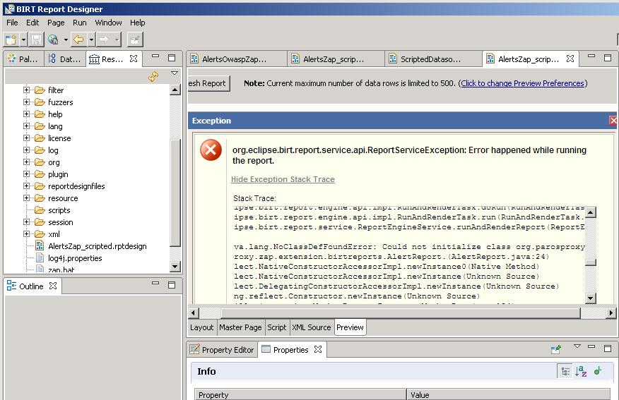
Figure: Error

1. First I moved the BIRT report to the \bin of ZAP to see if that would allow BIRT to reference the ZAP java classes, I am calling from within the BIRT report designer (via javascript) but it did not work. It did just not understand the ZAP classes at all.

2. For the testing purpose, I imported a standard java package (java.util) via script in the BIRT report designer and executed a function from this package. This test worked which meant that for standard java packages, there is some reference already added into BIRT report designer and for ZAP, I have to add a reference but where...?

3. Then, after some reading, I added the path to the ZAP bin directory in the classpath of BIRT design. It helped and BIRT report designer picked up the ZAP java classes but failed to instantiate the Model object and threw the following error:

The reason I understood that the ZAP classes I was calling from, within the BIRT report designer, in turn, called Model object. So, the BIRT report designer tried to create the Model object but failed.

Moreover, I think it is not a good way that we have to add classpath to BIRT report designer to make the script call to ZAP classes to work. Because this should all be happening at runtime so there should be a way or workaround that the BIRT report does not need to be fed the classpath.

Solution:
In order to resolve the above issues, I followed an alternative approach. Instead of having a method in the BIRT report template to retrieve data from the ZAP code, I sent the required data (Alerts) from the ZAP code to the template. This alternative has even eliminated the need of setting classpath in the report template. For the report to generate at runtime, we require “Alerts” data object to be available in the report. So, I passed the data object at runtime to ZAP report.

Final Implementation:
- Create a new BIRT Report using BIRT report designer. A sample report layout is shown in the figure below:

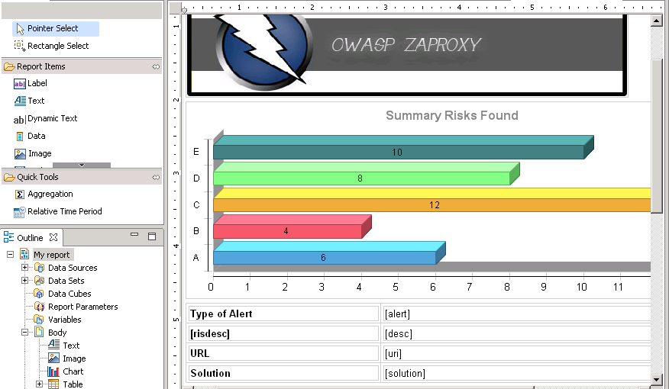
Figure 1: Sample Layout

- In the above figure, a header is placed on the top which has a logo inside it. Then a summary chart is in the middle. At the bottom, a table is placed which is mapped to a dataset.

- Create a data source; Right click on “Data Sources” in the Outline pane on the left side and select “New Data Source”. A dialog box shall appear in which select “Scripted Data Source” and click on the “Finish” button as shown below:

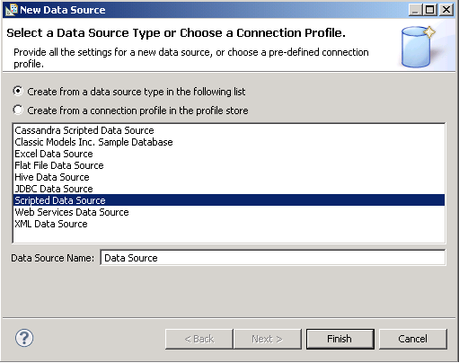
Figure 2: New Data Source

- Create a Data Set; Right click on “Data Sets” and select “New Data Set”. Choose the scripted data source created in the previous step. In our case, it is ‘dsAlerts’.

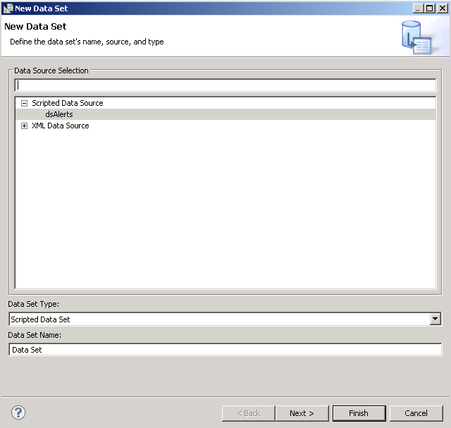
Figure 3: New Data Set
- Then configure the dataset by adding the columns you shall require to include in the table as shown in the figure 1. In our case, we have defined the following columns. These columns define our data that shall be coming into BIRT from ZAP using a script.

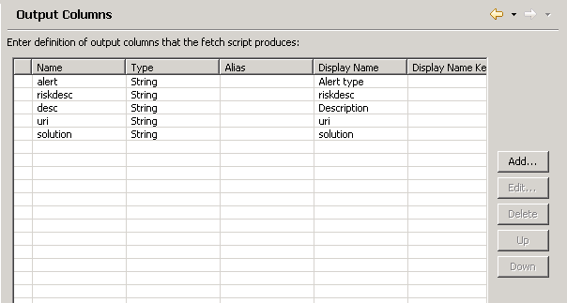
Figure 4: Data Set columns

- By now, we have created a report template. Now we need to write scripts that will bring the data into the report template. The scripts are as follows:

Select the data set from the Outline pane and click on the script tab from the middle pane. Two scripts are required to be written; one for the “open” event and the other one for the “fetch event”.

In the “open” event, type the following:
count = 0;
importPackage(Packages.java.util.*);
globalVarList = new java.util.ArrayList();
appContext = reportContext.getAppContext();

globalVarList = appContext.get("Alerts");

In the “fetch” event, type the following:
if (count < globalVarList.size())
{
row["alert"] = globalVarList.get(count).getAlert();
row["desc"] = globalVarList.get(count).getDescription();
row["riskdesc"] = globalVarList.get(count).getRisk();
row["uri"] = globalVarList.get(count).getUri();
row["solution"] = globalVarList.get(count).getSolution();

count++;
return true;
}
return false;

Save the report and make sure it is placed in the /reportdesignfiles folder under zaproxy\zap\extension\birtreports. So at the runtime, ZAP can pick up this report.

In ZAP code, under ‘birtreports’extension, I made the following additions to link ZAP code with the BIRT report.

Created a new menu option called “Generate BIRT Report (scripted)” using Messages.properties file.

Created BirtScriptMenu.java file to handle the logic when a user clicks on the above menu option.

Added a method “executeBirtScriptReport” in “ReportLastScan.java” and called it from the BirtScriptMenu.java class.

Build the Run the program and the code will produce a BIRT report. The generated report shall also cater the grouping of Alerts which was previously done for XML data source BIRT reports as well. Such grouping of the same category of alerts, is configurable using a property “birt.report.count” in Messages.properties file.

